**Note:**

1. **The program does not restrict the user from entering any non letter characters. It the removes all the non letter characters except space.**
2. **The program only deals with letters (capital or small) and space.**
3. **If the user enters digits or punctuations or symbols the program removes from the string.**

# Results:

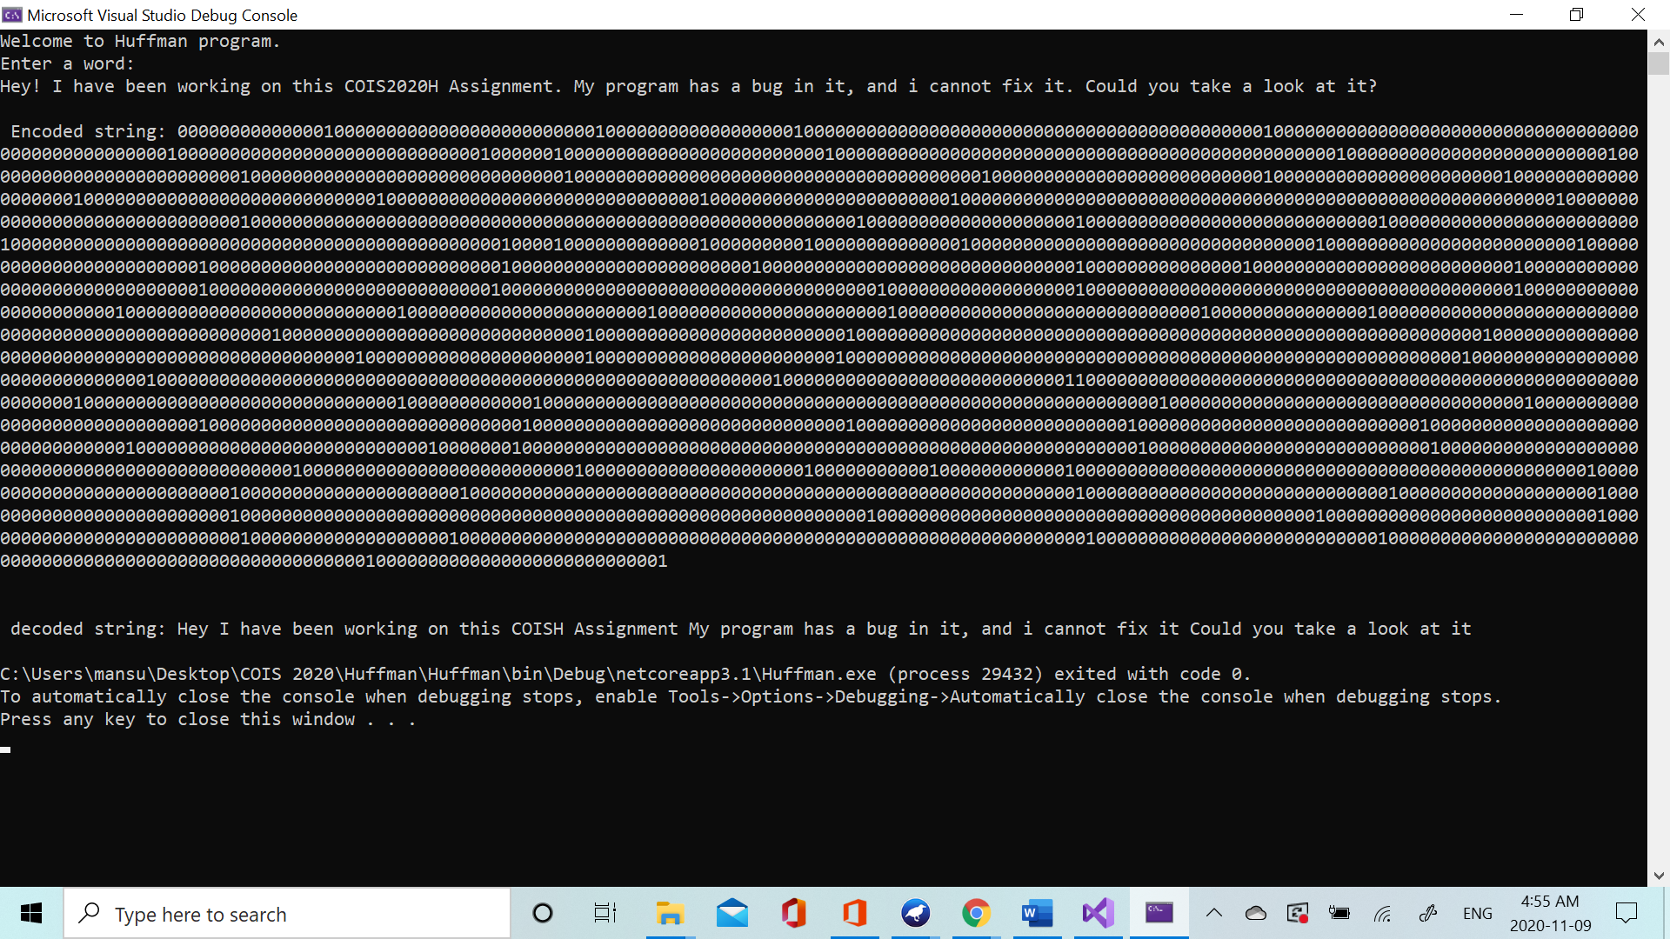

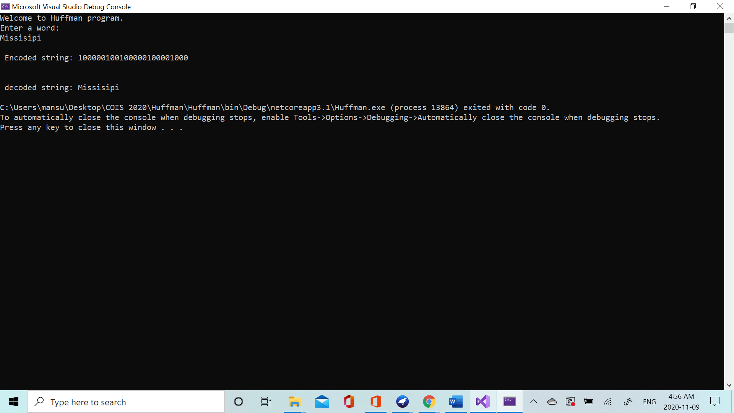

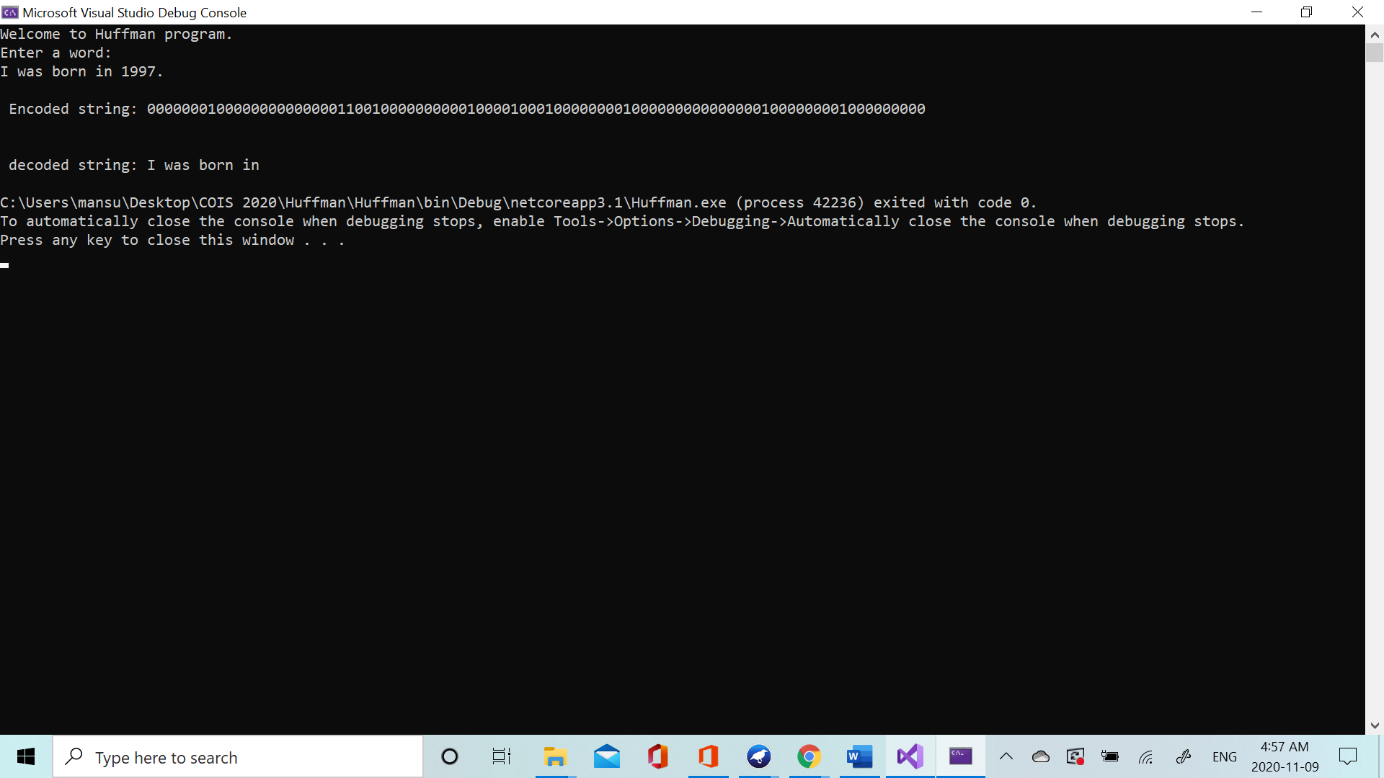

**@sam**

**See if you can find anything extreme case that I forgot to consider in this program. And let me know.**

**I have set up this program in a way that it removes all the other characters except the letter characters and space. May be double check the professor if that is good.**